Asia-China-Shang-Bronze-Jue-Sothebys

## [A bronze tripod wine vessel (jue), Late Shang Dynasty, 12th -11th century BC](http://www.alaintruong.com/archives/2013/09/07/27973680.html)

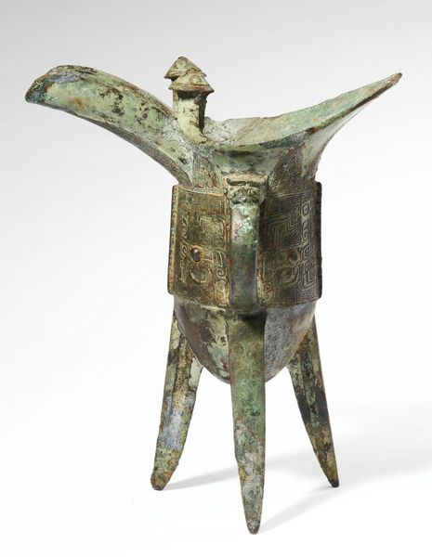

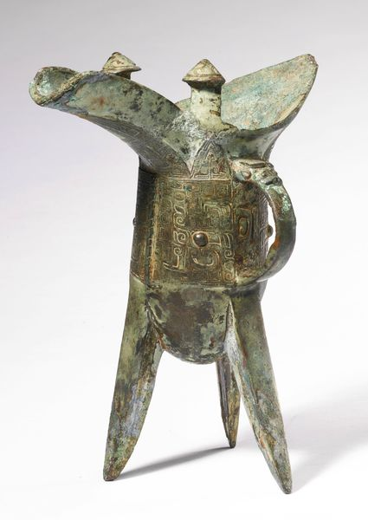

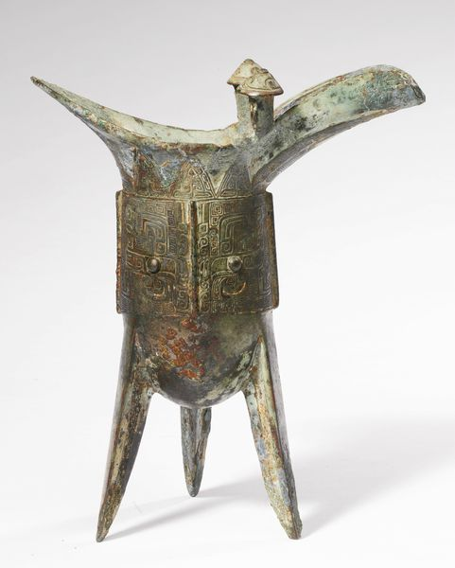

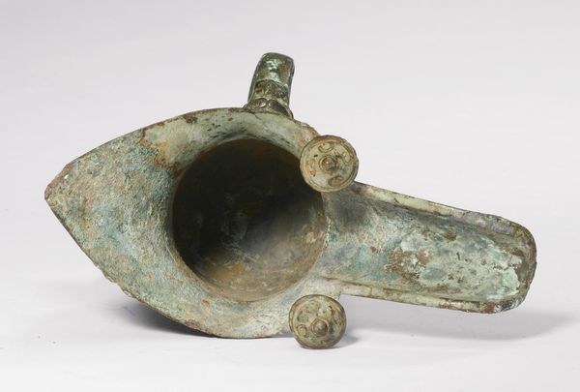

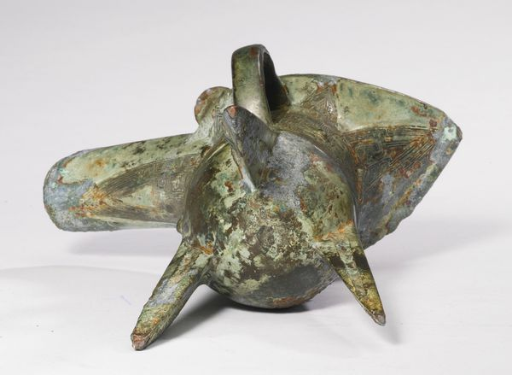

A bronze tripod wine vessel (**jue**), Late Shang Dynasty, 12th -11th century BC. Photo: Sothebys.

the elongated U-shaped body supported on three slender, splayed blade legs, well-cast with a pair of taotie formed from two raised bosses for eyes and disassociated hooks and scrolls enclosing leiwenforming both the features of the mask as well as avian beaks and feathers, one divided by shallow notched flange, the other by a single pictogram comprised of two elements ge and er cast under the C-scroll handle surmounted by a bovine head, all below a row of upright triangular blades enclosing further leiwen, the rim set with two rectangular posts terminating in whorl-incised domed caps, the silvery-green patina with some patches of malachite encrustation. Height 7 3/8  in., 18.8 cm. Estimation 30,000 — 40,000 USD

Provenance: Collection of Ethel Graves Sarkisian (1911-1999), Denver and thence by descent.